**Project Report**

**ON**

**QUIZ MANAGEMENT SYSTEM**

**BACHELOR OF SCIENCE**

**IN**

**INFORMATION TECHNOLOGY**

**SUBMITTED BY**

* Akshay Paritosh(16070124008)
* Anshul Sharma(16070124013)
* Prince Chaudhary(16070124017)
* Shivali Ranka(16070124055)



**Under the Guidance of**

**PROF. POOJA V. KAMAT**

**SYMBIOSIS INSTITUTE OF TECHNOLOGY**

**(A CONSTITUTENT OF SYMBIOSIS INTERNATIONAL UNIVERSITY)**

**Pune - 412115**

**2018-19**

**“Introduction”**

This document will propose all features and procedures to develop the online application for Quiz Management System.

This document specially contain details about objectives scope limitations, process model, primary requirements , team development, possible project risks, project schedule and finally monitoring and reporting mechanisms.

This Quiz Management System is very useful for Educational institutes to prepare an exam, save the time that is required for checking the paper. The effective use of this Quiz Management System for any Educational institute or training centers is to develop the strategy for conducting the Exams, and for getting better results in less time.

The best application is it will help us to choose best students of our needed standards required, as in military and in other secret departments.

* 1. **Purpose**
* The purpose of this document is to specify the functional and non functional requirements with primary goals of implementation.
* It includes both the definition of user-requirements and specification of system requirements.
* This document briefly describes the objectives of the project and set out the constraints (e.g. Budget, time, quality, limitations etc.) that affects the management of the project.
  1. **Document Conventions**

The following are the list of conventions used in the used in the document and project as well:

* Administrator: A login id representing a user with user administration privileges to the software.
* User: A general login id assigned to the user.
* Client: Intended Users for the software.
* Examiner: checks the test and gives the result.

* 1. **Intended audience and reading suggestions**

This document is created for:

* The instructor of the course “Software Engineering” and “Java and Web Technology” for their review and monitoring progress of the project.
* The software development team for their use in analyzing the requirements.
* This project is an implementation of quiz management system and it can be used within the college premises. This has been designed under the guidance of college professors. The project is useful for the teachers as well as for the students for a fast and speedy examination.

**1.4 Scope and Features of project**

Providing accessibility to the administrators who have a valid user-Id and password. This system also provides the following facilities such as-

* ‘n’ number of students can participate in the quiz at a time (as we are using real-time firebase database that can automatically scale-up or scale-down).
* Automation of result generation of all individual participants.
* Based on the requirements of the organization or institutions all the quiz details (including negative marking) are entered by the admin user.
* Quiz management system is designed such that it can be used for educational institutes (like schools, colleges, basic educational training centers).
* The response (includes simultaneous broadcast read operations send by the server from a single database) of the software is around 1, 00,000/second.

**1.5 References**

* Java reference 9th edition by oracle for JavaScript.
* Stack overflow for taking students in random.
* Github docs for JSP Servlet.
* Code project
* AskMetaFilter for enforcing time limit on the webpage.
* Edureka! For implementing JavaScript Countdown Timer in an online quiz application.
* <https://www.codeproject.com/Questions/289124/select-random-data-from-database>
* <http://grokbase.com/t/gg/firebase-talk/1577afvesc/firebase-selecting-random-child>
* <https://stackoverflow.com/questions/45145596/get-random-item-from-firebase>
* <https://ask.metafilter.com/23762/HTMLJavascript-enforcing-time-limit-on-webpage>
* <https://www.edureka.co/blog/creating-an-online-quiz-application-implementing-countdown-timer/>
* <https://www.edureka.co/blog/creating-an-online-quiz-application-using-jsp-servlet/>
* <https://www.digitalocean.com/community/tutorials/how-to-add-javascript-to-html>
* <https://stackoverflow.com/questions/42268002/how-do-i-access-the-child-nodes-nested-inside-child-node-in-firebase-database>
* <https://stackoverflow.com/questions/19269545/how-to-get-n-no-elements-randomly-from-an-array>
* <https://firebase.google.com/docs/database/web/read-and-write>
* <https://www.codeproject.com/Questions/289124/select-random-data-from-database>
* <https://firebase.google.com/docs/reference/js/firebase.database.Reference>
* <https://console.firebase.google.com/u/1/project/jwtproject-1aa76/database/jwtproject-1aa76/data>
* <https://stackoverflow.com/questions/45145596/get-random-item-from-firebase>

1. **Overall Description**

This software is responsible for recording and automating the task of conducting online quiz. It makes faster working and good services with efficient user interaction.

* Describing the scope of the work.
* Providing framework for testing primary and secondary use-case.
* Facilitating reviews on quizzes.
* Product functions.
* Constraints, assumption and dependencies.
* Transparent conduct of examination.
* It would provide time as soon as test starts.
* Result sheet of individual student will be generated at the end.

**2.1 Product Perspective**

The proposed Quiz Management System is an online exam system and has following stages:

* **Login:**

Login by the student or the faculty for different implementation of the software.

* **Test:**

Test to be given by the students and conducted by respective faculties.

* **Update:**

Database can be updated/edited by the teachers. Teachers can add, delete or modify the questions in the database.

* **Result:**

Result of the students will be displayed by the software at the end of the quiz. A graphical or pie-chart representation of the result can also be displayed.

**2.2 Product Functions**

The product includes many functionalities of the organization. These functionalities are:

* New student registration.
* User database management.
* Score evaluation.
* To conduct test.
* Security management.
* Transparent conduct of Examination.
* It will also provide time as soon as test start.

**2.3 User classes and characteristics**

There are various kinds of users for the product. Usually web products are visited by various users for di6erent reasons. The users include :

* Chancellor who will be acting as the controller and he will have all the privileges of administrator.
* Students who will be using the above features by accessing the online instructions available.
* Examiner who will prepare: load database into the software.
  1. **Operating Environment**

Windows operating system has been used for both, programming and testing.

* Google cloud functions for firebase.
* JavaScript
* HTML
* Materialize CSS
* Cloud Firestore (If requested to scale-up or scale-down)
* Firebase database
* Google cloud CLI
* jQuery plug-in
  1. **Design and Implementation constraints**

The design time constraints are:

* ‘n’ number of students can give the quiz at a time and all will be having a different set of questions with them.
* The database of this software is managed by using Google Firebase and speed of the quiz depends upon the internet connectivity and load on the database system.
* JavaScript command has been used to implement the functions of this software.
  1. **Process Model**

Model used in the project is “Incremental Model”.

Reasons for using this model are: This model fitted best for our project. We can make and then test smaller modules and then further upgrade it into a new version.

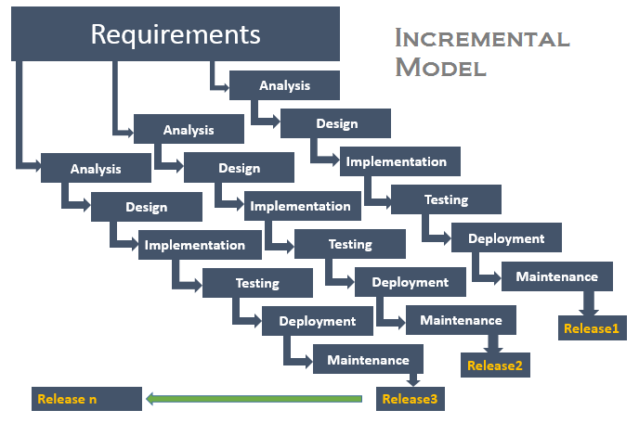

* 1. **Assumptions and Dependencies**
* We assume all users have basic computer knowledge and also our quiz system provides good user interface and help section to help the user at any moment during visit to the website.
* For creating the WebPages and setting up the core program, tools such as sublime text, JavaScript compiler, etc., were used that affects overall rhythm of the software for better understanding of the basics of the codes that were used to design the software.

**3. Functional Requirements**

This section gives a functional requirement that is applicable to the Online Quiz Management System. Initially, general requirements that pertain to the whole system are given and then possible subsequent requirements have been demarcated based on their relevance to the users of the system that is Student, Faculty and admin. Below shows the functional requirements:-

**3.1 Faculty Requirement**

**3.1.1 Faculty Login**

**Input: -** Username and Password.

**Output: -** Display screen for selecting subject & year.

**3.1.2 Conducts Test**

**Input: -** Selecting subject and year from drop-down menu.

**Output: -** Test starts and student is able to access the test page.

**3.1.3 Modify Question Bank**

**Input: -** Selecting options like add delete and modify from drop-down menu.

**Output: -** Faculty can perform any of the above mentioned operation.

**3.1.4 Generate Result**

**Input: -** Select the batch and date.

**Output: -** Result is displayed.

**3.2 Student Requirements**

**3.2.1 Student Registration/Login**

**Input: -** Username and password.

**Output: -** If permitted by the faculty, test begins.

If not, Error message is shown.

**3.2.2 Answers the quiz**

**Input: -** Selects the answer for question and click on the submit button.

**Output: -** If test is completed within time limit, then submit the test.

If not, then question will be displayed on the screen.

**3.2.3 View Result**

**` Input: -**  Select the subject from the drop-down menu.

**Output: -** Result is displayed.

**3.3 Admin Requirements**

**3.3.1 Validation of the faculty**

**Input: -** Enter username and password along with the respective faculty name.

**Output:-**A message is displayed showing whether the faculty is successfully added to the database or not.